Hemocyanin (Hc) is found in all three kindoms of life. In eukaryotes, Hc is found primarily in mollusk, tunicates, and arthropods.

* Arthropods and molluscs have structurally different hemocyanins[1]
* Arthropod HC is composed of kidney shaped subunits[1]

Hemocyanin is a type-3 copper protein. Type 3 proteins are found in all three animal kingdoms but their origin and early evolution are not well understood. The ancestral type-3 copper protein gene underwent two duplication events, first prior to divergence of unikont eukaryotic organisms and second before the diversification of animals. Hc in arthropods evolved from a beta-subclass tyrosinase and mollusk and tunicate Hemocyanin evolved independently from an alpha-subclass tyrosinase [4]. “

“Minor conformational changes at the active site of α, β and γ forms can produce type-3 copper proteins with capacities to either carry oxygen (hemocyanins), oxidize diphenols (catechol oxidase) or o-hydroxylate monophenols (tyrosinases) and appear to underlie some functional convergences [4].”

The study by Martin-Duran, et al in 2013 identified new animal species with hemoerthrin, hemocyanin M and tyrosinase domains in their genomes [5].

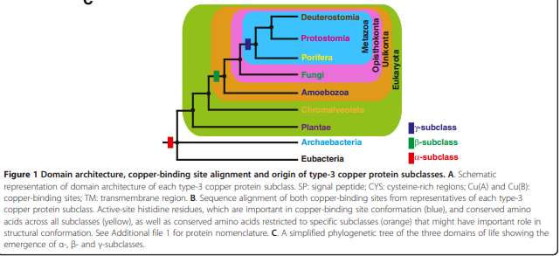

**Thoughts:**

If we are interested in the evolution of hemocyanins and why they provide an evolutionary advantage, I think we need to look into the biological role of type-3 copper proteins and their role in oxygen metabolism. The presence of all three type-3 copper proteins across all kingdoms of life and the major speciation event before the diversification of animals (where the presence of hemoglobin first emerges???) leads me to believe that hemocyanin may have been the original oxygen transport molecule with catechol oxidase and tyrosinase further facilitating oxygen metabolism.

[1] Coates, C. J., & Decker, H. (2017). Immunological properties of oxygen-transport proteins: hemoglobin, hemocyanin and hemerythrin. *Cellular and molecular life sciences : CMLS*, *74*(2), 293–317. <https://doi.org/10.1007/s00018-016-2326-7>

[2] van Holde KE, Miller KI, Decker H. Hemocyanins and invertebrate evolution. *J Biol Chem*. 2001;276(19):15563-15566. doi:10.1074/jbc.R100010200

[3] Waxman L. The structure of arthropod and mollusc hemocyanins. *J Biol Chem*. 1975;250(10):3796-3806.

[4] Aguilera, F., McDougall, C. & Degnan, B.M. Origin, evolution and classification of type-3 copper proteins: lineage-specific gene expansions and losses across the Metazoa. *BMC Evol Biol* **13,**96 (2013). <https://doi.org/10.1186/1471-2148-13-96>

[5] Martín-Durán, J. M., de Mendoza, A., Sebé-Pedrós, A., Ruiz-Trillo, I., & Hejnol, A. (2013). A broad genomic survey reveals multiple origins and frequent losses in the evolution of respiratory hemerythrins and hemocyanins. *Genome biology and evolution*, *5*(7), 1435–1442. <https://doi.org/10.1093/gbe/evt102>